import cv2
import numpy as np

if __name__ == '__main__':
im_src = cv2.imread("C:/Users/Bindu/OneDrive/Pictures/Screenshots/house 1.png")
im_dst = cv2.imread("C:/Users/Bindu/OneDrive/Pictures/Screenshots/house 2.png")

if im_src is None or im_dst is None:
exit()

pts_src = np.array([[141,131], [480,159], [493,630], [64,601]], dtype=np.float32)

h_dst, w_dst = im_dst.shape[:2]
pts_dst = np.array([[0,0], [w_dst-1,0], [w_dst-1,h_dst-1], [0,h_dst-1]], dtype=np.float32)

h, _ = cv2.findHomography(pts_src, pts_dst)

im_out = cv2.warpPerspective(im_src, h, (w_dst, h_dst))

cv2.imshow("Source Image", im_src)
cv2.imshow("Destination Image", im_dst)
cv2.imshow("Warped Image", im_out)

cv2.waitKey(0)
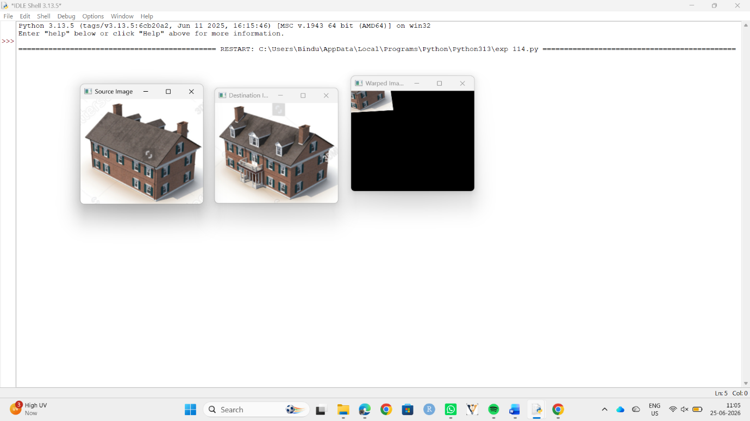
cv2.destroyAllWindows()

